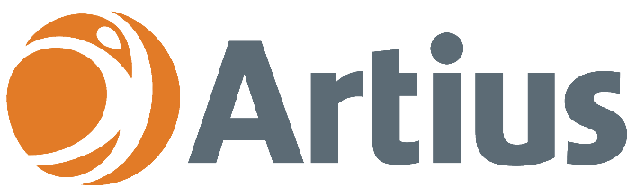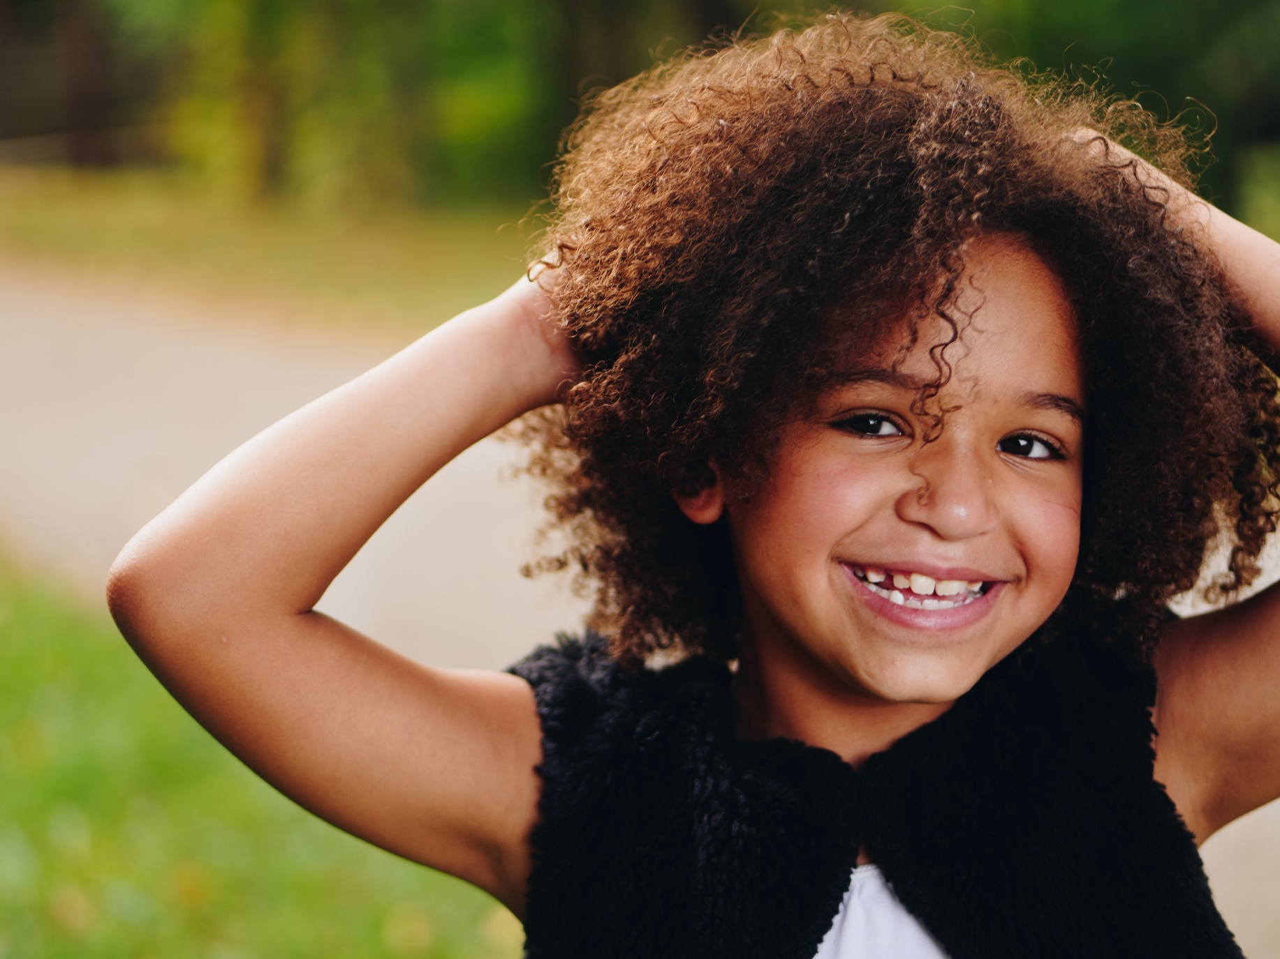

# Artius Health helps people, businesses and communities to reach their potential.

# Artius Health delivers a wide range of Mental Health Services

# Our friendly and experienced team of clinicians are here to help

**Artius Health provides a range of   
Mental Health Services for Kids**

Who are we?

Artius Health is one of QLD’s largest private practices and has been providing quality Mental Health Services since 2005.

How can we help?

Our team of caring and experienced clinicians have a passion for helping children who are struggling with:

* Anxiety, fears and avoidance behaviour
* Depression, low mood and grief & loss
* Low self-esteem and self-confidence
* Bullying, friendship and social concerns
* Resilience and growth mindset difficulties
* Anger and behavioral difficulties
* Adjustment concerns
* Symptoms of ADHD and ASD.

Where are we?

Our clinics are located in the Gold Coast (Helensvale), Ipswich, Gympie, Sunshine Coast (Birtinya & Maroochydore) and Rockhampton regions.

Did you know?

* You don’t need a referral to access our services; however,   
  Medicare rebates can apply with a valid Mental Health Care Plan.
* Health Care Card and Pension Card holders are **bulk-billed**.
* We accept NDIS, EAP, DVA, Better Access, EPC,   
  WorkCover, Private Insurance & PHN referrals.

Referrals

Please send referrals via fax, email or Medical Objects.

Contact Us

**p: 07 5644 9777  
 f: 07 5502 7414  
 e: health@artius.com.au**

**w: artius.com.au**

# 

**Psychological Assessments are Now Available at Artius**

**MENTAL HEALTH SERVICES FOR KIDS**