* 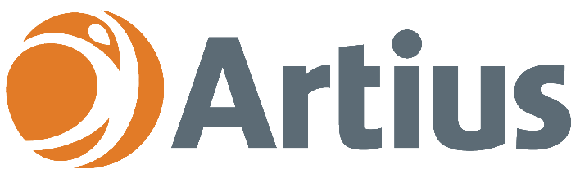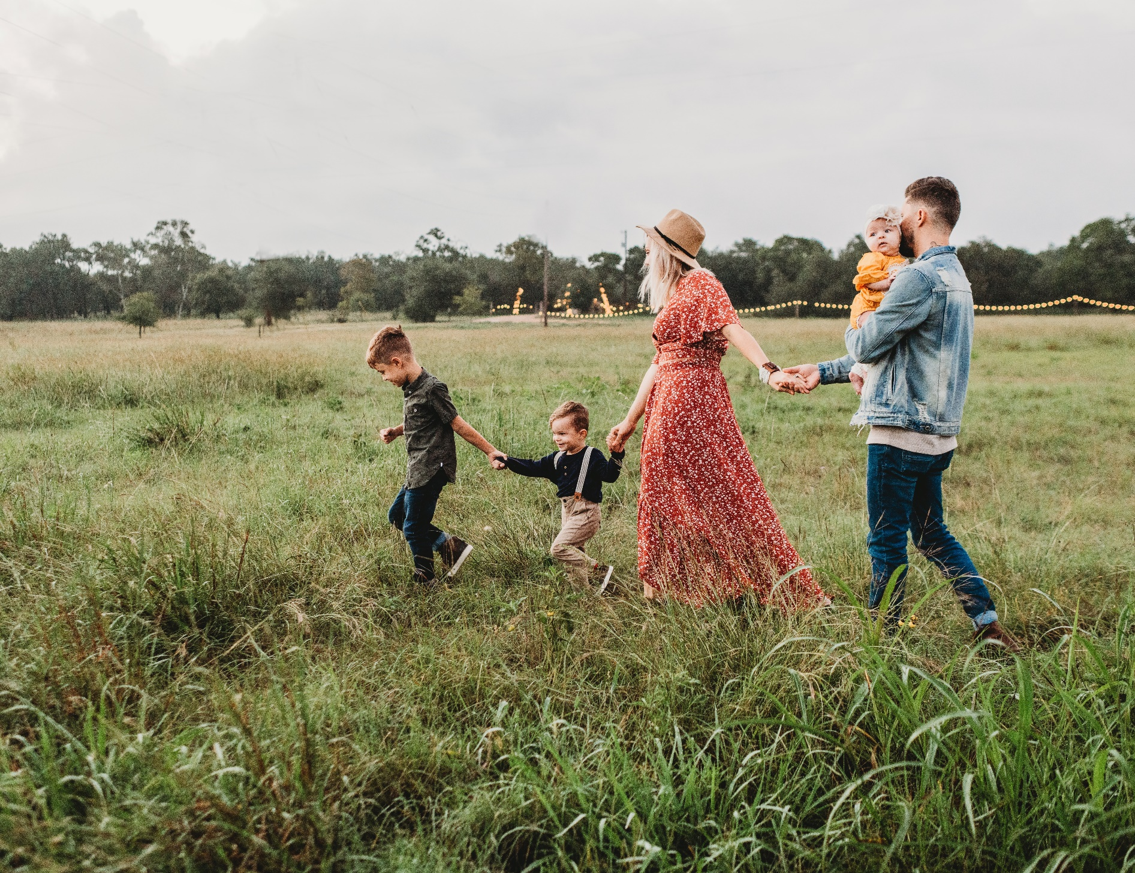

# Artius Health helps people to reach their potential

# Artius Health delivers a wide range of Mental Health Services

# Our friendly and experienced team of clinicians are here to help

**Artius Health provides a range of   
Mental Health Services for Families**

Who are we?

Artius Health is one of QLD’s largest private practices and has been providing quality Mental Health Services since 2005.

What is Family Therapy?

Family therapy helps families from all backgrounds to transition through the various stages of the family life cycle and achieve continuous wellbeing.

‘Families’ can include biological, blended, grandparent, extended, fostered & adopted members. Not all members need to attend for therapy to occur.

How can we help?

Our team of caring and experienced clinicians can provide:

* Family Assessments
* Family Therapy
* Dyadic Developmental Psychotherapy
* Parent Child Interaction Therapy (PCIT) (modified)
* Circle of Security Model Counselling

What are the benefits of Family Therapy?

Family therapy can help to:

* Enhance communication & problem-solving skills
* Develop deeper empathy, relationships & attachments
* Reduce conflict & develop anger management skills
* Manage challenging situations (e.g. death, illness or adolescent issues)
* Create healthy boundaries, patterns & dynamics in the home.

Where are we?

Our clinics are located in the Gold Coast (Helensvale), Ipswich, Gympie, Sunshine Coast (Birtinya & Maroochydore) and Rockhampton regions.

Referrals

f: 07 5502 7414

e: [health@artius.com.au](mailto:health@artius.com.au)

Medical Objects: ArtiusHealthCare   
  
Contact Us

**p: 07 5644 9777 | e:** [**health@artius.com.au**](mailto:health@artius.com.au) **| w: artius.com.au**

# 

**FAMILY THERAPY**